**Name:** V Venkata Sri Prasad

**Batch:** Data Engineering

**Date:** 15/02/2024 – (Day 21)

Topics:

1. Database vs datawareshouse vs data lake vs Delta Lake
2. Creating Storage account, containers and uploading data in it

Creating a storage account:

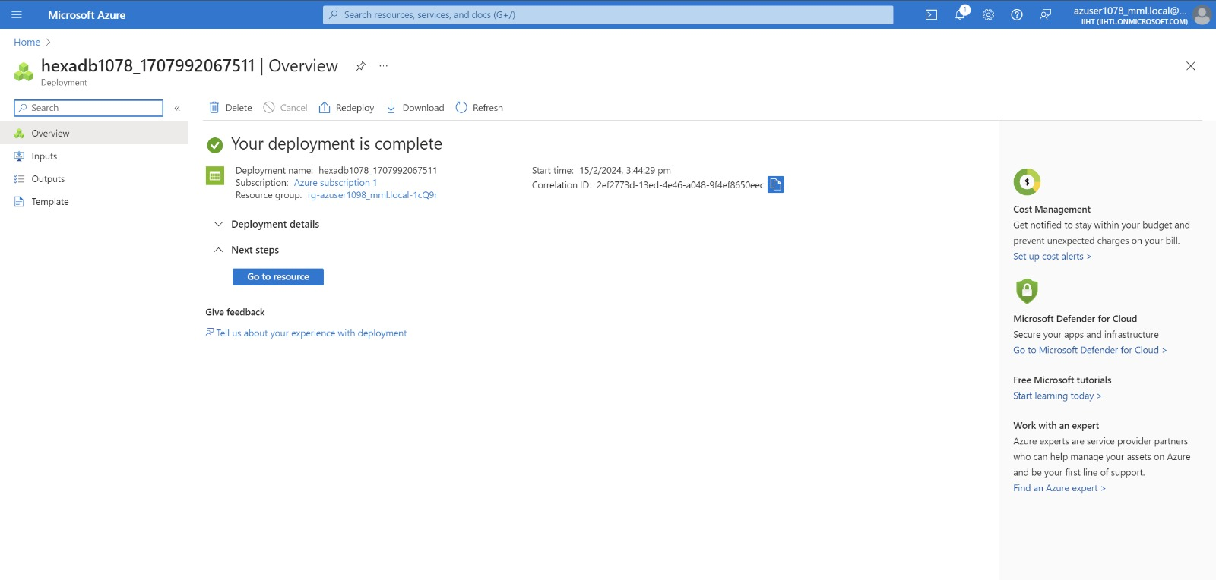

Creating a new container:

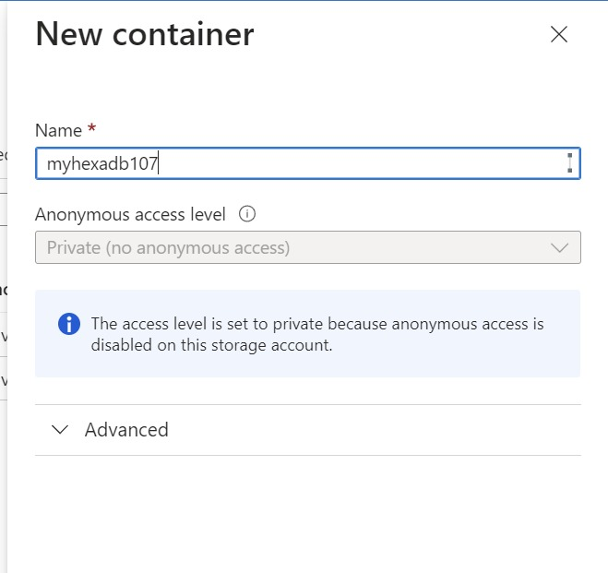

Open Shared access Signature and allow resource types:

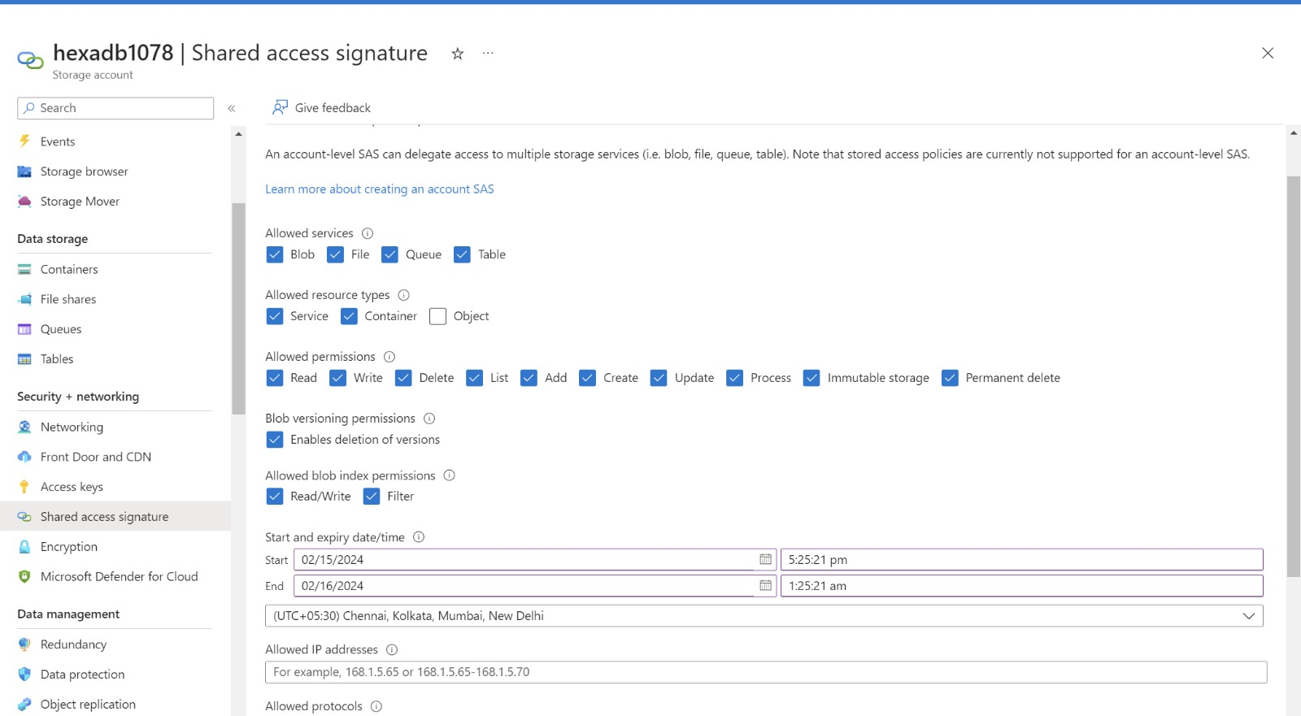

Provide the IP address:



Copy the Blob serive SAS url:

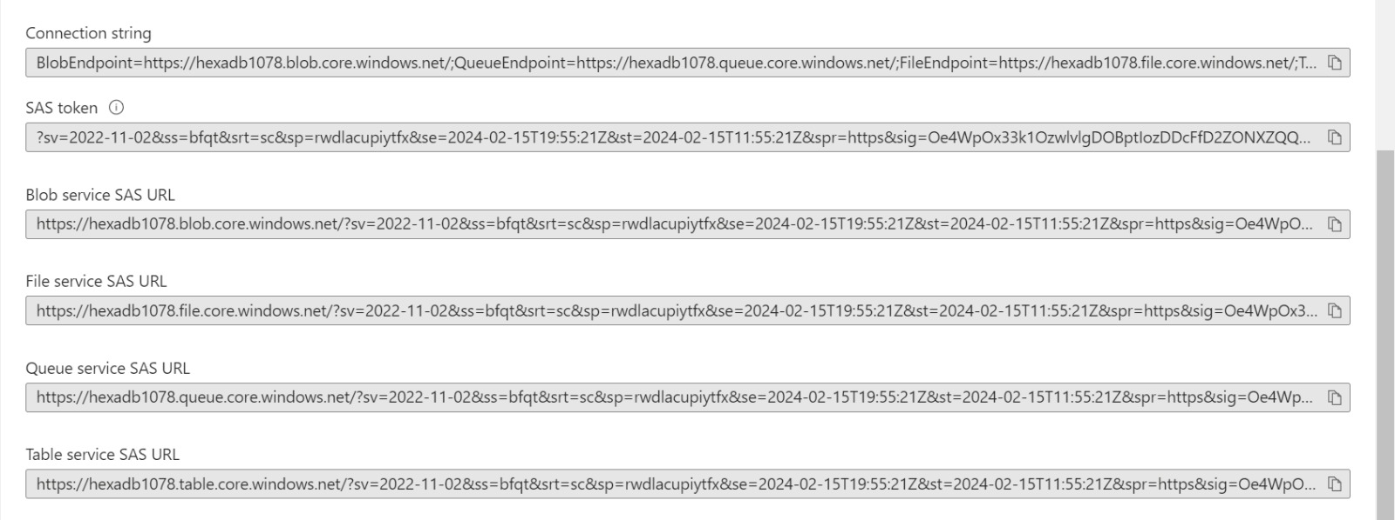

In the other hand download Explorer Service:

Connect to azure storage account and click on shared access url and paste the SAS url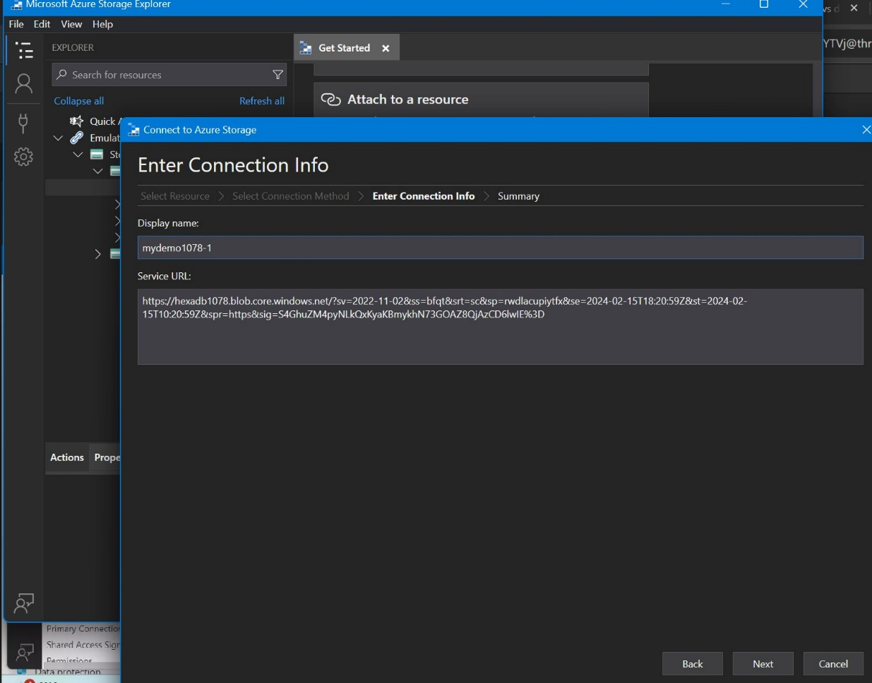

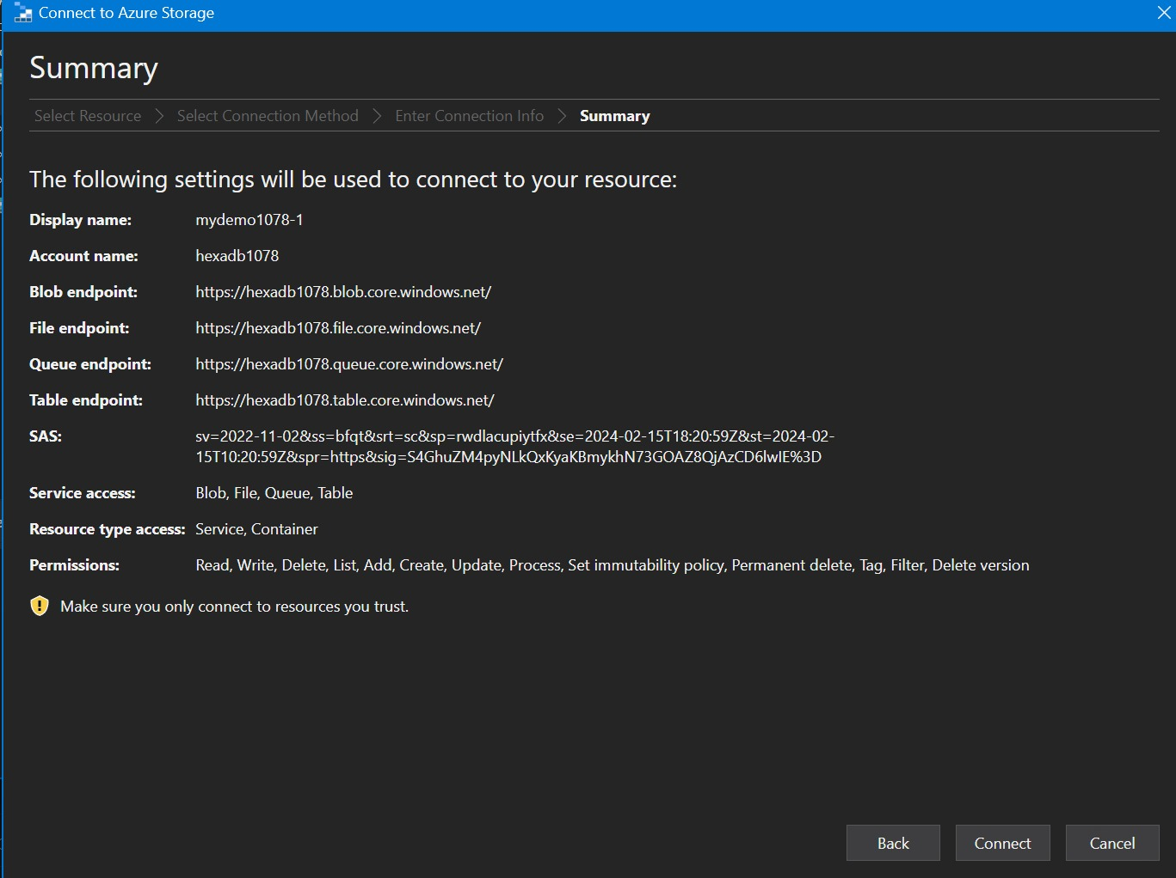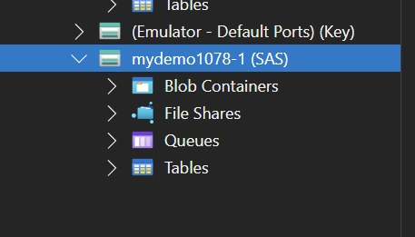

Now upload data in azure storage account:

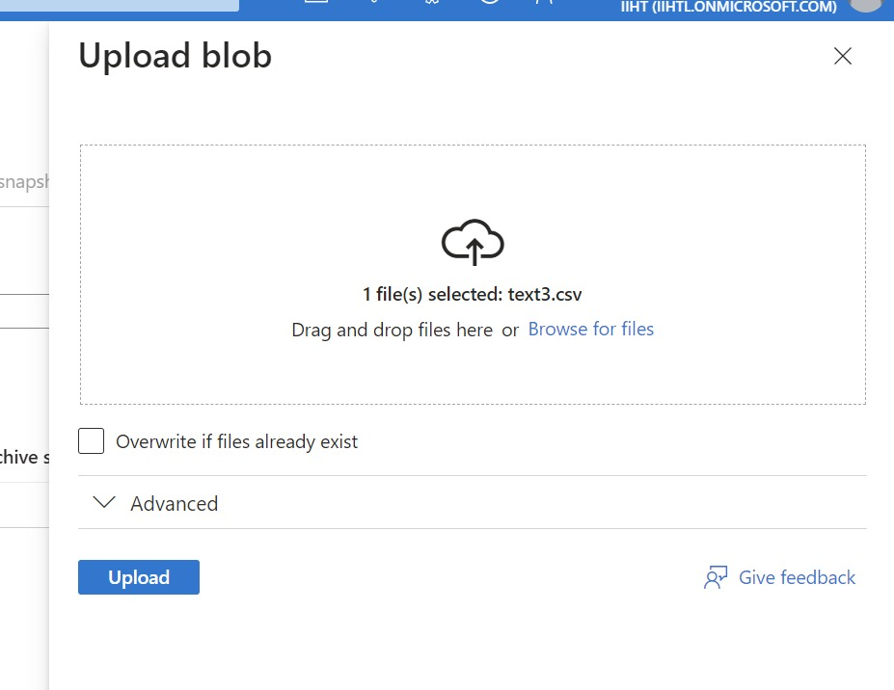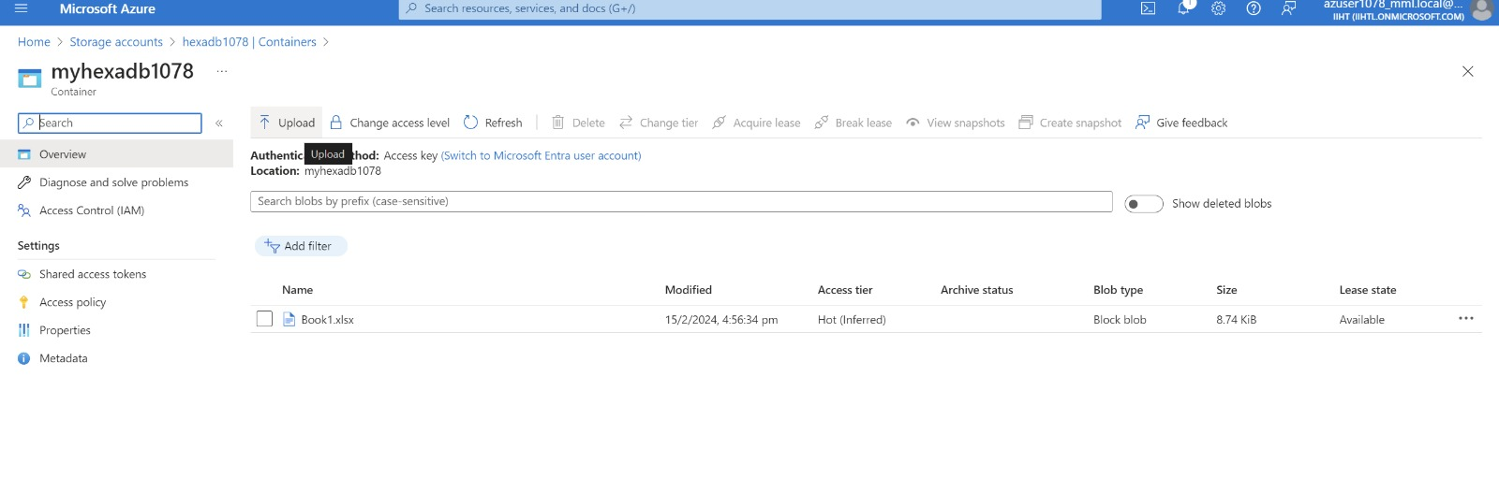

Notes:

